Pitchers Sikes, Rossman earn player of year honors
By Jim Lamar Democrat associate editor
June 12, 2011
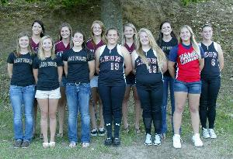
"The 2011 Class 3A-4A-5A All-Big Bend softball team. Front row (left to right): Courtney Davis, Florida High; Chandler Seay, Florida High; Caitlyn Coffey, Florida High; LG Zeegers, Leon; Annette Prather, Leon; Michael Cooper, Wakulla. Back row: Austyn West, Chiles; Anna Martin, Chiles; Samantha Martin, Chiles; Katie Baker, Chiles; Taylor Rossman, Florida High (Player of the Year); Drew Thomas, Leon. Not pictured: Wakulla's Kieifi Myrick and Brooklyn Tyndall, and Rickards' Victoria Robinson and Jessica Bigbie. - AMANDA NALLEY/Democrat

